**Ultrasonic Range Finder**

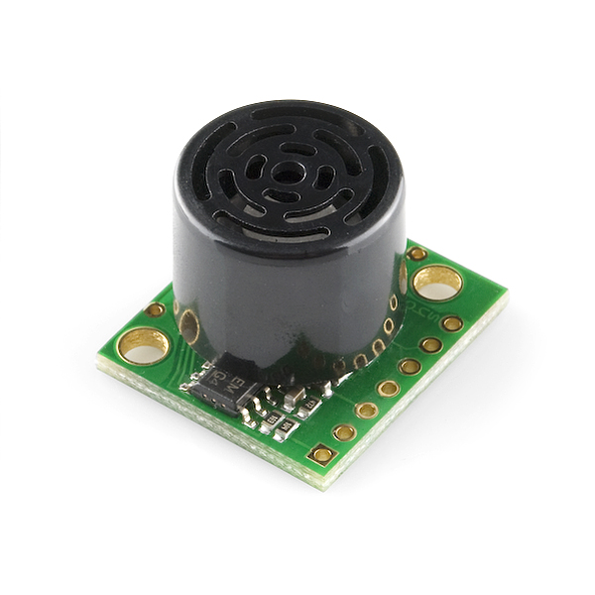

**What It Does**: The range finder sends out pulse of ultrasonic (inaudible) sound and listens for reflections. Based upon how long it takes for the pulse to return, the sensor can roughly measure distance.

**What It Tells You**: The range finder reports distance from the nearest object. The pulse expands as it leaves the sensor and objects not directly in front of the sensor can be detected. The minimum range is a few inches, up to a maximum range of 30 inches.

**Required Connects**:   
+5: this pin powers the range finder and should be connected to **5V** on the Arduino.  
GND: this pin is ground and should be connected to **Ground/GND**.  
AN: is the analog output of the range finder. This should be connected to an **Analog Input**.

**Using the Range Finder in Scratch:**

Use a *value of sensor* block to read in from the selected Analog Input. You will need on block for each axis. Adjust the pull down menu in the block to select the proper pin.

E:\My Dropbox\PhD\IDSA Workshop\Images\valueOfBlock.png

Read Data from Analog Input 0

Also, it will be helpful to store the reading into an appropriately named variable.

E:\My Dropbox\PhD\IDSA Workshop\Images\ReadInRange.png

Read Sensor Measurement into a Variable

The raw sensor measurement needs to be converted into physical units as shown below. The sensor data in Range is converted into a new variable, Inches, that is the distance in inches.

E:\My Dropbox\PhD\IDSA Workshop\Images\ConvertRange.png

Convert Raw Sensor Measurement Into Inches

In the example below, the distance measured by the range finder is used with blocks from the *Sound* group. A tone is played is an object is detected 20 inches away, otherwise there is no sound.

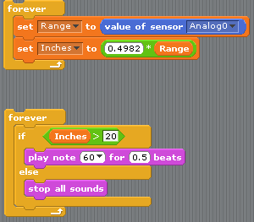

Range Finder Example